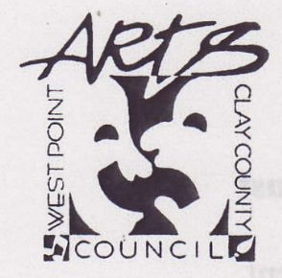

West Point—Clay County Arts Council

Norman Armstrong Arts in Education
Mini-Grant Program
2026-2027

Guidelines and Eligibility

The Arts in Education Mini-Grant Program of the West Point—Clay County Arts Council is designed to facilitate and advance the arts as an integral component of the education and experience of K-12 students and educators in West Point and Clay County.

Teachers in both public and private schools may apply for mini-grants to support art experiences in the visual arts, music, drama, dance, or creative writing. Grant money can be used for supplies, teaching materials or equipment exclusive to the arts, tickets or admission to arts performances, teacher training workshops in arts education, or other activity that will enhance the integration of the arts into the classroom.

Guidelines
- Deadline for 2026-2027: Postmarked by January 13, 2027
- Funds are disbursed to the school business office
- Funds must be spent during the school year of the request.
- Funds may not be spent on standard classroom supplies.
- A follow-up report on the project is to be submitted within two weeks of a dated event or at the end of the semester for general support.

Eligibility
- All schools (K-12), both public and private operating in West Point and Clay County.
- All teachers in all subjects. Fine Arts teachers are especially encouraged to apply.
- Priority will be given to schools which demonstrate the most need, and which have not already received funding during respective grant year.
West Point—Clay County Arts Council
Arts in Education Mini-Grant Application
Please type or print clearly

School Name________________________________________________________

Principal’s Name____________________________________________________

Phone___________________________

Applicant’s Name (teacher)____________________________________________

Email_____________________________________________________________

Subject Area _______________________Grade Level (s)____________________

Number of participating students and/or teachers___________________________

Grant Amount Requested $_________________ ($500 Maximum)

Project date(s)________________

Attach to this form no more than a one page description of the project, materials, supplies, event, workshop, or other activity that you are requesting funds to implement. The narrative should include the need or problem this grant will help address. Explain the benefit of your proposal and how it fits with the general mission of the school or district.

If it is an event or performance, outline the main activities of the event and your teaching strategies both before and after the event that will enhance the experience of the students. Brochures or other information about the event should also be attached.

Provide a detailed budget that covers how the grant money will be spent. Also include information about any matching funds for this project that you have already secured. (For example: budgeted funds for this project, PTA assistance, student fees, parental contributions, fundraisers etc.)

Submit proposals to
West Point—Clay County Arts Council
P.O. Box 105
West Point, MS 39773

